
TITLE OF THESIS

10-LINE SPACE

STUDENT NAME SURNAME

10-LINE SPACE

MONTH AND YEAR OF THESIS DEFENSE

ÇANKAYA UNIVERSITY
A one-line space should be left between the pieces of information

GRADUATE SCHOOL

CHOOSE DEPARTMENT
SELECT PROGRAM SELECT PROGRAM TYPE

An 8-line space should be left.

TITLE OF THESIS

An 8-line space should be left.
If the title spans more than one line, this space may be reduced.

STUDENT NAME AND SURNAME

A 5-line space should be left.

MONTH AND YEAR OF THESIS DEFENSE

Title of Thesis: Should Be Written with Capital Letters for the First Letter of Each Word

Submitted by: Name SURNAME

Approval by the Graduate School of Çankaya University
A one-line space should be left between the pieces of information
_____________________
Prof. Dr. Mehmet YAZICI
Director

I certify that this thesis satisfies all the requirements as thesis for the Select Program Type degree in SELECT PROGRAM
_____________________
Prof. Dr. XXXX XXXXX
Head of Department

This is to certify that I have read this thesis and that in my opinion it is fully adequate in scope and quality, as thesis for the Select Program Type degree in SELECT PROGRAM
  _____________________
  Prof. Dr. XXXX XXXXX
  Co-Supervisor
  _____________________
  Prof. Dr. XXXX XXXXX
  Supervisor
  The thesis defense date must be written in the DD.MM.YYYY format.
  The jury members section must be filled out. The area following the university name is the signature space; this area must not be removed.
If there is no co-supervisor, this table should be removed.

Thesis Defense Date:
Thesis Jury Members:
Prof. Dr. XXX XXX | Çankaya University | _____________________
Assoc. Dr. XXX XXX | …………………………... | _____________________
……………………….. | ………………………...… | _____________________
……………………….. | ……………………….….. | _____________________
……………………….. | …………………………… | _____________________

STATEMENT OF NONPLAGIARISM

I hereby declare that all statements in this statement has been obtained and presented in accordance with academic rules and ethical conduct. I also declare that, as required by these rules and conduct, I have fully cited and referenced all material and results that are not original to this work.

Name Last Name:
Signature:
Date:
The date on which print approval was obtained must be entered in the date section of this declaration page. This section must be filled in by hand using a blue pen.

ABSTRACT
The page margin for headings
at the top should be 5 cm.
There must be a one-line space between the abstract, the thesis title, and the surname/name. There must be a one-line space before the advisor information and before the start of the abstract.

TITLE OF THESIS

LAST NAME, NAME
SELECT PROGRAM SELECT PROGRAM TYPE

Supervisor: Assoc. Prof. Dr. XXXXXXXXXX
Co-Supervisor: Assist. Prof. Dr. XXXXXXXXX
The year of the defense and the total number of pages must be stated.
August 2026, 18 Pages

Indented paragraph must be when starts to write thesis. First line option selects from paragraph settings and by section adjust 1.25 cm or press CTRL + TAB or TAB when you write abstract. Abstract should be written 12 Punto and Times New Roman, alignment should be justified and line spacing should be 1.5 lines
Line spacing should be 1.5 lines among paragraphs
…………….………………………………………………………………………………………………………………………………………………………………………………………………………………………………………………………………………………………………………………………………………………………………………………………………………………………………………………………………………………………………………………………………………………………………………………………………………………………………………………………………………………………………………………………………………………………………………………………………………………………

Keywords: It should be written at least 3 word maximum 6 words. Only first letter of keyword should be capital. Comma should be placed among keywords. Keyword should be started by giving 1 line space after the end of the abstract.

ÖZET
The year of the defense and the total number of pages must be stated.
There must be a one-line space between the abstract, the thesis title, and the surname/name. There must be a one-line space before the advisor information and before the start of the abstract.

TEZ BAŞLIĞI

SOYAD, AD
PROGRAM SEÇİNİZ PROGRAM TÜRÜ SEÇİNİZ TEZİ

Danışman: Prof. Dr. Xxxx
Ortak Danışman: Doç. Dr. Xxxx
The year of the defense and the total number of pages must be stated.
Ağustos 2026, 18 Sayfa

...........................................................................................................................................................................................................................................................................................................................................................................................................................
……………………………………………………………………………………………………………………………………………………………………………………………………………………………………………………………………….………………………………………………………………………………………….………………………………………………………………………………………….………………………………………………………………………………………….………………………………………………………………………………………….………………………………………………………………………………………….………………………………………………………………………………………….………………………………………………………………………………………….

Anahtar Kelimeler:

ACKNOWLEDGEMENT

………………………………………………………………………………………………………………………………………………………………………………………………………………………………………………………………………………………………………………………………………………………………….………………………………………………………………………………………….………………………………………………………………………………………….………………………………………………………………………………………….………………………………………………………………………………………….………………………………………………………………………………………….………………………………………………………………………………………….………………………………………………………………………………………….………………………………………………………………………………………….………………………………………………………………………………………….………………………………………………………………………………………….

TABLE OF CONTENTS

STATEMENT OF NONPLAGIARISM iii

ABSTRACT iv

ÖZET v

ACKNOWLEDGEMENT vi

LIST OF TABLE viii

LIST OF FIGURES ix

LIST OF SYMBOLS AND ABBREVIATIONS x

CHAPTER I 1

FIRST LEVEL TITLE 1

1.1 SECOND LEVEL TITLE 1

1.1.1 Third Level Title 1

1.1.1.1 Fourth Level Title 1
1.1.1.1.1 Fifth Level Title 1
1.1.1.1.1.1 Sixth Level Title 1

1.1.1.1.1.1.1 Seventh Level Title 1

CHAPTER II 2

HOW TO MAKE LIST OF TABLES AND FIGURES AND WHAT ARE THESE FORMATS ? 2

2.1 ARRANGE TABLE AND MAKE A TABLE OF LIST 2

2.2 HOW TO INSERT FIGURES AND HOW TO LISTED 3

CHAPTER III 4

ABOUT THE REFERENCES 4

3.1 RULES OF REFERENCES 4

REFERENCES 5

APPENDICES 6

APPENDIX 1: 6

LIST OF TABLE

Table 1: Information about Thesis 2
Table 2: Number of students in M.Sc. and Ph.D. 2

Information regarding the creation of tables and lists of tables is detailed in the thesis template under the heading SECTION II > 2. ARRANGE TABLE AND MAKE A TABLE OF LIST.

LIST OF FIGURES

Figure 1: Satellite view of Çankaya University 3
Figure 2: Second Satellite view of Çankaya University 3

Information regarding the insertion of figures and the creation of a list of figures is detailed in the thesis template under the heading SECTION II > 2.2 HOW TO INSERT FIGURES AND HOW TO LISTED.

LIST OF SYMBOLS AND ABBREVIATIONS

SYMBOLS

ABBREVIATIONS
cm | :Centimetre

The list of symbols and abbreviations must be in table format; each symbol and abbreviation should be listed in a separate row, with its explanation in a separate column.

CHAPTER I
Section headings must begin 5 cm from the top of the page. On subsequent pages within the same section, the text should begin 2.5 cm from the top of the page. The required spacing must not be created by inserting blank lines. Leave one blank line after the section heading, and then insert the Level 2 heading. If a Level 3 heading follows immediately after a Level 2 heading, no blank line should be inserted between them.

FIRST LEVEL TITLE

Style - Heading 1 must be selected which is founded in section Home- Style in word to First Level Title. All level titles are arranged in Styles section. You can reach more information from Thesis Manuel.

SECOND LEVEL TITLE
Style – Heading 2 must be selected which is founded in section Home- Style in word to Second Level Title.

Third Level Title
Style – Heading 3 must be selected which is founded in section Home- Style in word to Third Level Title.

Fourth Level Title

Fifth Level Title

Sixth Level Title

Seventh Level Title

CHAPTER II
Section headings must begin 5 cm from the top of the page. On subsequent pages within the same section, the text should begin 2.5 cm from the top of the page. The required spacing must not be created by inserting blank lines. Leave one blank line after the section heading, and then insert the Level 2 heading. If a Level 3 heading follows immediately after a Level 2 heading, no blank line should be inserted between them.

HOW TO MAKE LIST OF TABLES AND FIGURES AND WHAT ARE THESE FORMATS ?

ARRANGE TABLE AND MAKE A TABLE OF LIST
For a basic table, click Insert > Table and move the cursor over the grid until you highlight the number of columns and rows you want. For a larger table, or to customize a table, select Insert > Table > Insert Table. After your table is arranged, to write your tables explanations top your tables. you can follow these steps; Home > Styles > Table Writing, Figure Writing. You can create and update your table list with these steps; References > Instert Tables of Figures > General > Caption Label > Table. One line space must be before table explanation and end of the table.

Table 1: Information about Thesis
Heading of Tables | Page Number | Number of Article

Table 2: Number of students in M.Sc. and Ph.D.
Bölüm | Öğrenci Sayısı | Tez Sayısı
 | M.Sc.
Computer Engineering | 15 | 5
 | Ph.D.
Design | 3 | 1
Toplam | 18 | 6
It is designed for exemplary purposes

HOW TO INSERT FIGURES AND HOW TO LISTED
On subsequent pages, the text begins 2.5 cm from the top of the page.
For adding any figure to your thesis. Insert > Picture. You must be organized figure with these steps; Picture Layout > In Line with Text and its’ alligment must be centered. After your picture is arranged, to write your tables explanations bottom side of your figures. you can follow these steps; Home > Styles > Table Writing, Figure Writing. You can create and update your figure list with these steps; References > Instert Tables of Figures > General > Caption Label > Figure. One line space must be before figure and after explanation of the figüre.

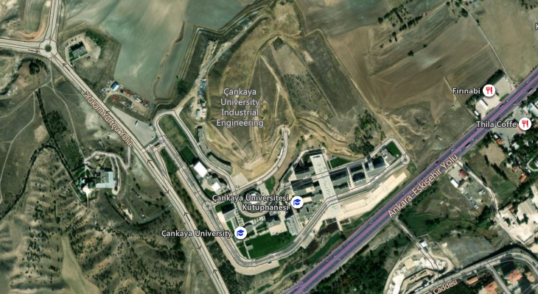
Figure 1: Satellite view of Çankaya University

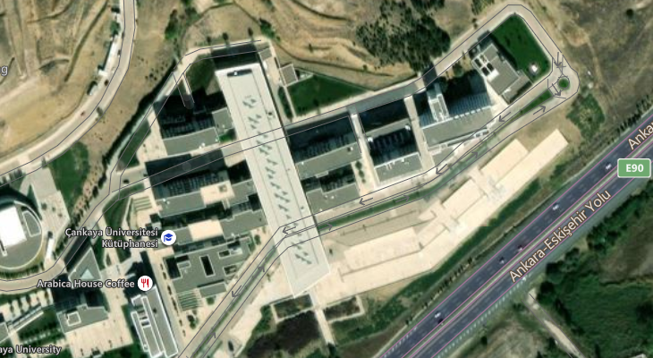
Figure 2: Second Satellite view of Çankaya University

CHAPTER III

ABOUT THE REFERENCES

RULES OF REFERENCES
Our University has its own rules regarding the presenting citiations which are used in your thesis in bibliography section. It is obligatory to use the Thesis Manuel, how to specify sources such as articles, books, journals.

REFERENCES
The reference list format is shown below. References must be formatted using Paragraph > Indentation > Special > Hanging > 1.25 cm in Microsoft Word and must be justified.Depending on the citation style used in the text, references should be presented in one of the following formats: the numeric citation style or the author–date citation style, as illustrated below.

IT’S ARRANGED ACCORDING TO NUMERICAL METHOD.

[1] JARAD Fahd ve ABDELJAWAD Thabet (2020), “Variational Principles İn The Frame Of Certain Generalized Fractional Derivatives”, Ame. Ins. of Math. Sci., Vol. 13, No. 3, pp. 695-708.
[2] ÇETİNKAYA Ferda Can (1994), “Lot Streaming in a Two-stage Flow Shop with Set-up, Processing and Removal Times Separated”, Journal of the Operational Research Society, Vol 45, pp.. 1445–1455.
[3] DEMİRCAN Tolga, TÜRKOĞLU Haşmet (2005), “Çarpan Osilasyonlu Laminar Jetlerin Akış ve Isı Transferi Karakteristiklerinin Sayısal Analizi”, 15. Ulusal Isı Bilimi ve Tekniği Kongresi, pp.. 543-549, Trabzon.

IT’S ARRANGED ACCORDING TO AUTHOR-DATE METHOD.

ÇETİNKAYA Ferda Can (1994), “Lot Streaming in a Two-stage Flow Shop with Set-up, Processing and Removal Times Separated”, Journal of the Operational Research Society, Vol. 45, pp. 1445–1455.
DEMİRCAN Tolga, TÜRKOĞLU Haşmet (2005), “Çarpan Osilasyonlu Laminar Jetlerin Akış ve Isı Transferi Karakteristiklerinin Sayısal Analizi”, 15. Ulusal Isı Bilimi ve Tekniği Kongresi, pp. 543-549, Trabzon.
JARAD Fahd ve ABDELJAWAD Thabet (2020), “Variational Principles İn The Frame Of Certain Generalized Fractional Derivatives”, Ame. Ins. of Math. Sci., Vol. 13, No 3, pp. 695-708.

APPENDICES

APPENDIX 1:

